**GROCERY APP**

**TITLE** : To build an grocery app by using android.

**SOFTWARE REQUIRED** : android studio.2021.2.1 and some other tools.

**INTRODUCTION** :

An online grocer is either a [brick-and-mortar](https://en.wikipedia.org/wiki/Brick_and_mortar) [supermarket](https://en.wikipedia.org/wiki/Supermarket) or [grocery store](https://en.wikipedia.org/wiki/Grocery_store) that allows online ordering, or a standalone [e-commerce](https://en.wikipedia.org/wiki/E-commerce) service that includes grocery items.There is usually a delivery charge for this service. Brick-and-mortar supermarkets that have built internet channels to better service their clients are known as online grocers. Online grocery delivery services are available throughout Europe, Asia and North America, mostly in urban centers. The online ordering is done through [e-commerce](https://en.wikipedia.org/wiki/E-commerce) [websites](https://en.wikipedia.org/wiki/Website) or [mobile apps](https://en.wikipedia.org/wiki/Mobile_app).

The [COVID-19 pandemic](https://en.wikipedia.org/wiki/COVID-19_pandemic) greatly accelerated the growth of online grocers, and in the first few months of the pandemics online grocery shopping increased by 300%. In addition, first-time online grocery shoppers accounted for 41 percent of online grocery shoppers.The epidemic of COVID-19 has hastened the uptake of online grocery shopping. Pre-COVID-19 food shopping activity accounted for 9 percent of the market, but 63 percent of consumers worldwide purchased more groceries online after the outbreak than they did before they were socially isolated.

Most local online grocers have their own drivers. The most common type of personal delivery involves storing grocery inventory in a [warehouse](https://en.wikipedia.org/wiki/Warehouse) to deliver to customers once orders are placed. Another type of personal delivery which is less common is based on [just-in-time](https://en.wikipedia.org/wiki/Just_in_time_(business)) business in which there is no warehouse or [inventory](https://en.wikipedia.org/wiki/Inventory). In this type of delivery, customers place orders for next-day delivery. The online grocer shops for the groceries on the morning of the delivery day.

Some grocery fulfillment centers are set up as [dark stores](https://en.wikipedia.org/wiki/Dark_store). Online-only grocers typically have [warehouses](https://en.wikipedia.org/wiki/Warehouses) or [distribution centers](https://en.wikipedia.org/wiki/Distribution_centers) nearby, to allow local shipping of refrigerated items.

Online grocers with a large regional or national delivery area may ship groceries using courier services. If the order contains cold or frozen items, this involves "[flash freezing](https://en.wikipedia.org/wiki/Flash_freezing)" the goods and pack them into special shipping containers.

Companies have experimented with automated delivery modes including [drone delivery](https://en.wikipedia.org/wiki/Delivery_drone) and [robots](https://en.wikipedia.org/wiki/Robotics). For instance, in Fall 2016 [Washington, D.C.](https://en.wikipedia.org/wiki/Washington,_D.C.) approved a trial run of rolling delivery drones produced by [Star ship Technologies](https://en.wikipedia.org/wiki/Starship_Technologies). The earthbound robots are similar to wheeled coolers and carry around 40 pounds of groceries.

Online grocery stores may allow facilitating [local food](https://en.wikipedia.org/wiki/Local_food) which may reduce the environmental impact of food transport. Small-scale farmers have been embracing digital technologies as a way to sell produce directly, and [community-supported agriculture](https://en.wikipedia.org/wiki/Community-supported_agriculture) and direct-sell delivery systems are on the rise during the coronavirus pandemic.Furthermore, weekly grocery deliveries can be a better choice than individual trips to a store.

**STEPS FOR THE PROJECT:**

**STEP-1:Create a New Project**

To create a new project in Android Studio i refer to [How to Create/Start a New Project in Android Studio.](https://www.geeksforgeeks.org/android-how-to-create-start-a-new-project-in-android-studio/) Note that select **Java** as the programming language.

**STEP-2 : Add dependency of Slider View in build.gradle file**

Navigate to the Gradle scripts and then to build.gradle(Module) level. Add below line in build.gradle file in the dependencies section.

CODE:

// dependency for slider view

implementation ‘com.github.smarteist:autoimageslider:1.3.9’

// dependency for loading image from url

implementation “com.github.bumptech.glide:glide:4.11.0”

**STEP-3 : Add internet permission in the AndroidManifest.xml file**

Navigate to the **app > Manifest** to open the Manifest file and add below two lines.

CODE:

*<!–Permission for internet–>*

*<uses-permission android:name=”android.permission.INTERNET” />*

*<uses-permission android:name=”android.permission.ACCESS_NETWORK_STATE” />*

**STEP-4 : Working with the activity_main.xml file**

Go to the **activity_main.xml** file and refer to the following code. Below is the code for the **activity_main.xml** file.

CODE FOR XML :

<?xml version="1.0" encoding="utf-8"?>

<RelativeLayout

xml:android="http://schemas.android.com/apk/res/android"

xml:app="http://schemas.android.com/apk/res-auto"

xml:tools="http://schemas.android.com/tools"

android:layout_width="match_parent"

android:layout_height="match_parent"

tools:context=".MainActivity">

<!--

slider animation duration is to set duration for transition between two slides

sliderautocycledirection is to set animation between transition of your slides

slider indicator enables is used to display the indicators for slider

slider indicator gravity is to set gravity for indicator gravity

slider indicator margin is to set margin for indicator

slider indicator orientation is used to add orientation for slider

slider indicator padding is use to add padding to indicator

slider indicator selected color is use to specify selected color

and slider indicator unselected color is use to specify the color when the slider is unselected

slider scroll time in sec is used to specify scrolling time in seconds

-->

<com.smarteist.autoimageslider.SliderView

android:id="@+id/slider"

android:layout_width="match_parent"

android:layout_height="150dp"

android:layout_centerInParent="true"

app:sliderAnimationDuration="600"

app:sliderAutoCycleDirection="back_and_forth"

app:sliderIndicatorAnimationDuration="600"

app:sliderIndicatorEnabled="true"

app:sliderIndicatorGravity="center_horizontal|bottom"

app:sliderIndicatorMargin="15dp"

app:sliderIndicatorOrientation="horizontal"

app:sliderIndicatorPadding="3dp"

app:sliderIndicatorRadius="2dp"

app:sliderIndicatorSelectedColor="#5A5A5A"

app:sliderIndicatorUnselectedColor="#FFF"

app:sliderScrollTimeInSec="1" />

</RelativeLayout>

**STEP-5 : Create a new Modal class for storing data**

Navigate to app > java > your app’s package name and then right-click on it and New > Java class and name your Model class as **SliderData** and below code inside that Java class. Below is the code for the **SliderData.java** file. Comments are added inside the code to understand the code in more detail.

CODE FOR JAVA :

public class SliderData {

// image url is used to

public void setImgUrl(String imgUrl) {

this.imgUrl = imgUrl;

}

}

**STEP - 6: Create an XML file for the items of SliderView**

Navigate to the app > res > layout > Right-click on it and select New > Layout Resource File and then name your XML file as **slider_layout.xml**. After creating this file add the below code to it.

CODE FOR XML :

<?xml version="1.0" encoding="utf-8"?>

<RelativeLayout

xml:android="http://schemas.android.com/apk/res/android"

android:layout_width="match_parent"

android:layout_height="match_parent">

<!--Image we will display is our slider view-->

<ImageView

android:id="@+id/my image"

android:layout_width="400dp"

android:layout_height="300dp"

android:layout_centerHorizontal="true"

android:contentDescription="@string/app_name" />

</RelativeLayout>

**STEP - 7: Create Adapter Class for setting data to each item of our**

**SliderView**

Navigate to app > java > your app’s package name and then right-click on it and New > Java class and name your class as **SliderAdapter** and below code inside that Java class. Below is the code for the **SliderAdapter.java** file. Comments are added inside the code to understand the code in more detail.

CODE FOR JAVA :

import android.content.Context;

import android.view.LayoutInflater;

import android.view.View;

import android.view.ViewGroup;

import android.widget.ImageView;

import com.bumptech.glide.Glide;

import com.smarteist.autoimageslider.SliderViewAdapter;

import java.util.ArrayList;

import java.util.List;

public class SliderAdapter extends SliderViewAdapter<SliderAdapter.SliderAdapterViewHolder> {

// list for storing urls of images.

private final List<SliderData> mSliderItems;

// Constructor

public SliderAdapter(Context context, ArrayList<SliderData> sliderDataArrayList) {

this.mSliderItems = sliderDataArrayList;

}

// We are inflating the slider_layout

// inside on Create View Holder method.

@Override

public SliderAdapterViewHolder onCreateViewHolder(ViewGroup parent) {

View inflate = LayoutInflater.from(parent.getContext()).inflate(R.layout.slider_layout, null);

return new SliderAdapterViewHolder(inflate);

}

// Inside on bind view holder we will

// set data to item of Slider View.

@Override

public void onBindViewHolder(SliderAdapterViewHolder viewHolder, final int position) {

final SliderData sliderItem = mSliderItems.get(position);

// Glide is use to load image

// from url in your image view.

Glide.with(viewHolder.itemView)

.load(sliderItem.getImgUrl())

.fitCenter()

.into(viewHolder.imageViewBackground);

}

// this method will return

// the count of our list.

@Override

public int getCount() {

return mSliderItems.size();

}

static class SliderAdapterViewHolder extends SliderViewAdapter.ViewHolder {

// Adapter class for initializing

// the views of our slider view.

View itemView;

ImageView imageViewBackground;

public SliderAdapterViewHolder(View itemView) {

super(itemView);

imageViewBackground = itemView.findViewById(R.id.myimage);

this.itemView = itemView;

}

}

}

**STEP-8:** **Working with the MainActivity.java file**

Go to the **MainActivity.java** file and refer to the following code. Below is the code for the **MainActivity.java** file. Comments are added inside the code to understand the code in more detail.

CODE FOR JAVA :

import android.os.Bundle;

import androidx.appcompat.app.AppCompatActivity;

import com.smarteist.autoimageslider.SliderView;

import java.util.ArrayList;

public class MainActivity extends AppCompatActivity {

// Urls of our images.

String url1 = "https://www.geeksforgeeks.org/wp-content/uploads/gfg_200X200-1.png";

String url2 = "https://qphs.fs.quoracdn.net/main-qimg-8e203d34a6a56345f86f1a92570557ba.webp";

String url3 = "https://bizzbucket.co/wp-content/uploads/2020/08/Life-in-The-Metro-Blog-Title-22.png";

@Override

protected void onCreate(Bundle savedInstanceState) {

super.onCreate(savedInstanceState);

setContentView(R.layout.activity_main);

// we are creating array list for storing our image urls.

ArrayList<SliderData> sliderDataArrayList = new ArrayList<>();

// initializing the slider view.

SliderView sliderView = findViewById(R.id.slider);

// adding the urls inside array list

sliderDataArrayList.add(new SliderData(url1));

sliderDataArrayList.add(new SliderData(url2));

sliderDataArrayList.add(new SliderData(url3));

// passing this array list inside our adapter class.

SliderAdapter adapter = new SliderAdapter(this, sliderDataArrayList);

// below method is used to set auto cycle direction in left to

// right direction you can change according to requirement.

sliderView.setAutoCycleDirection(SliderView.LAYOUT_DIRECTION_LTR);

// below method is used to

// set adapter to slider-view.

sliderView.setSliderAdapter(adapter);

// below method is use to set

// scroll time in seconds.

sliderView.setScrollTimeInSec(3);

// to set it scrollable automatically

// we use below method.

sliderView.setAutoCycle(true);

// to start auto cycle below method is used.

sliderView.startAutoCycle();

}

}

OUTPUT :

1.By opening app .if you have an account give your mail and password.

if you don't have an account click on sign up.

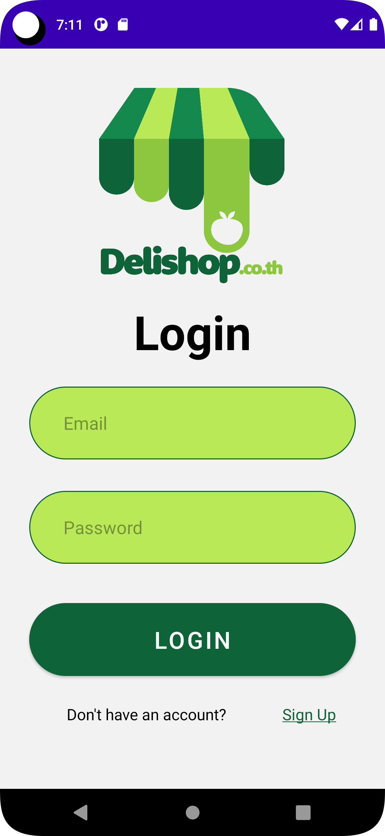

1. Then the app will be

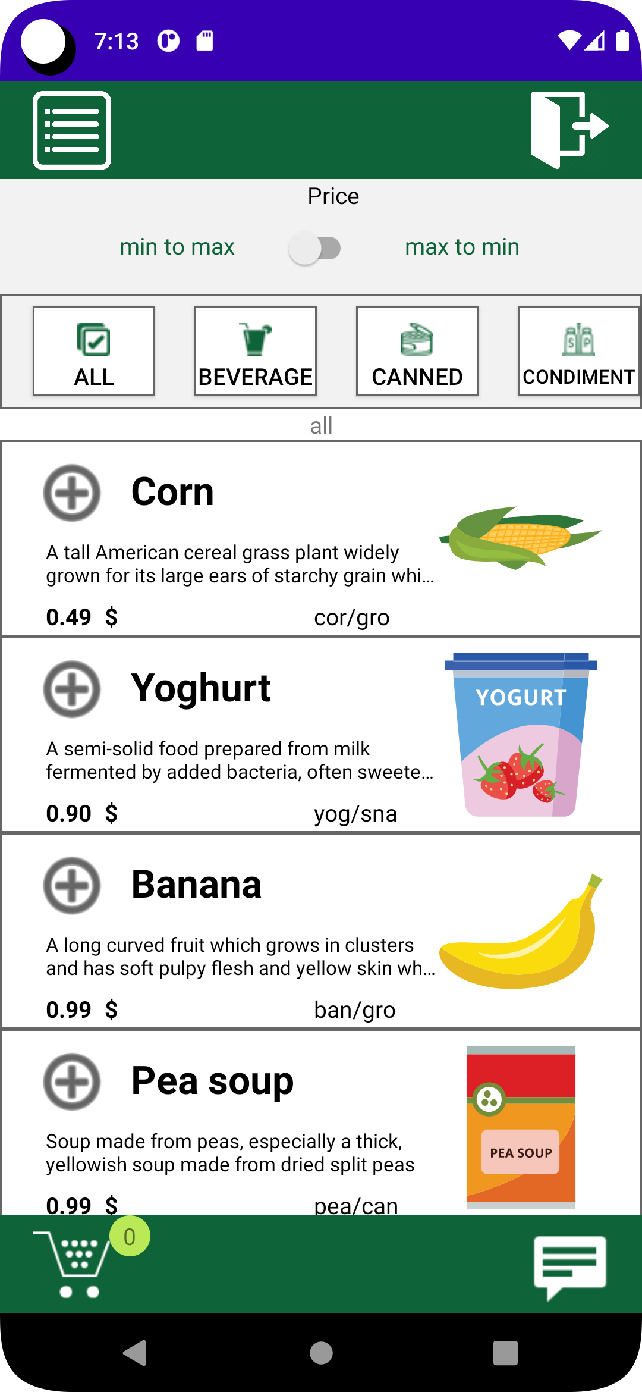

1. if we want Beverage then click on beverage .

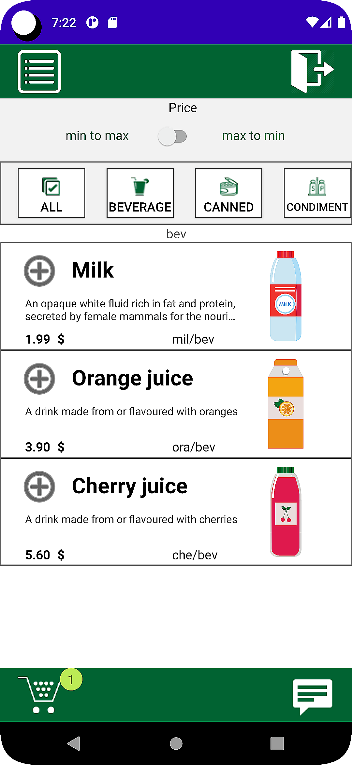

1. Alternatively, if we want canned then click on canned then the app will be

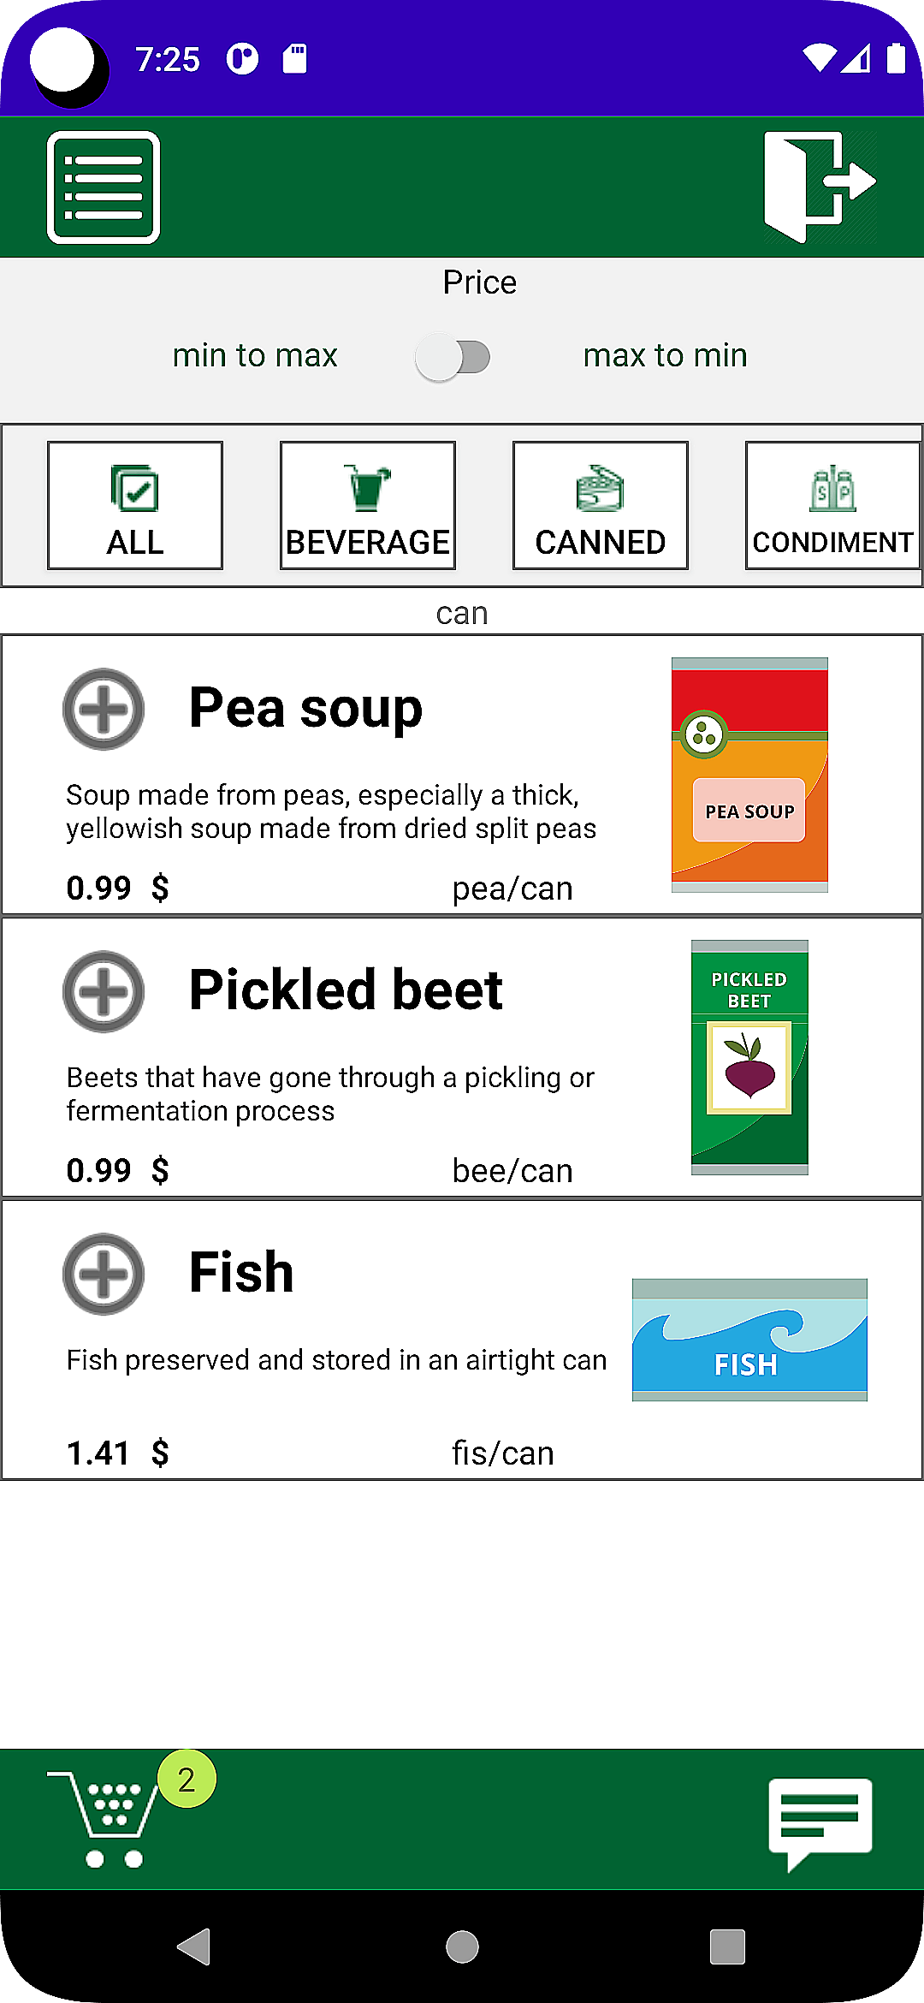

1. Alternatively, if we want condiment then click on condiment

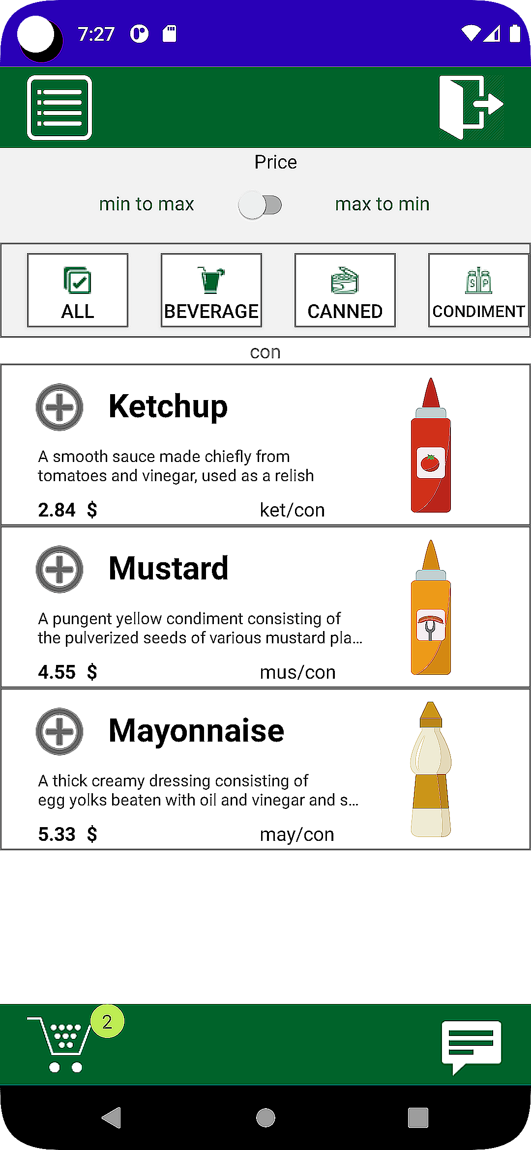

1. select the item we want then the payment will be

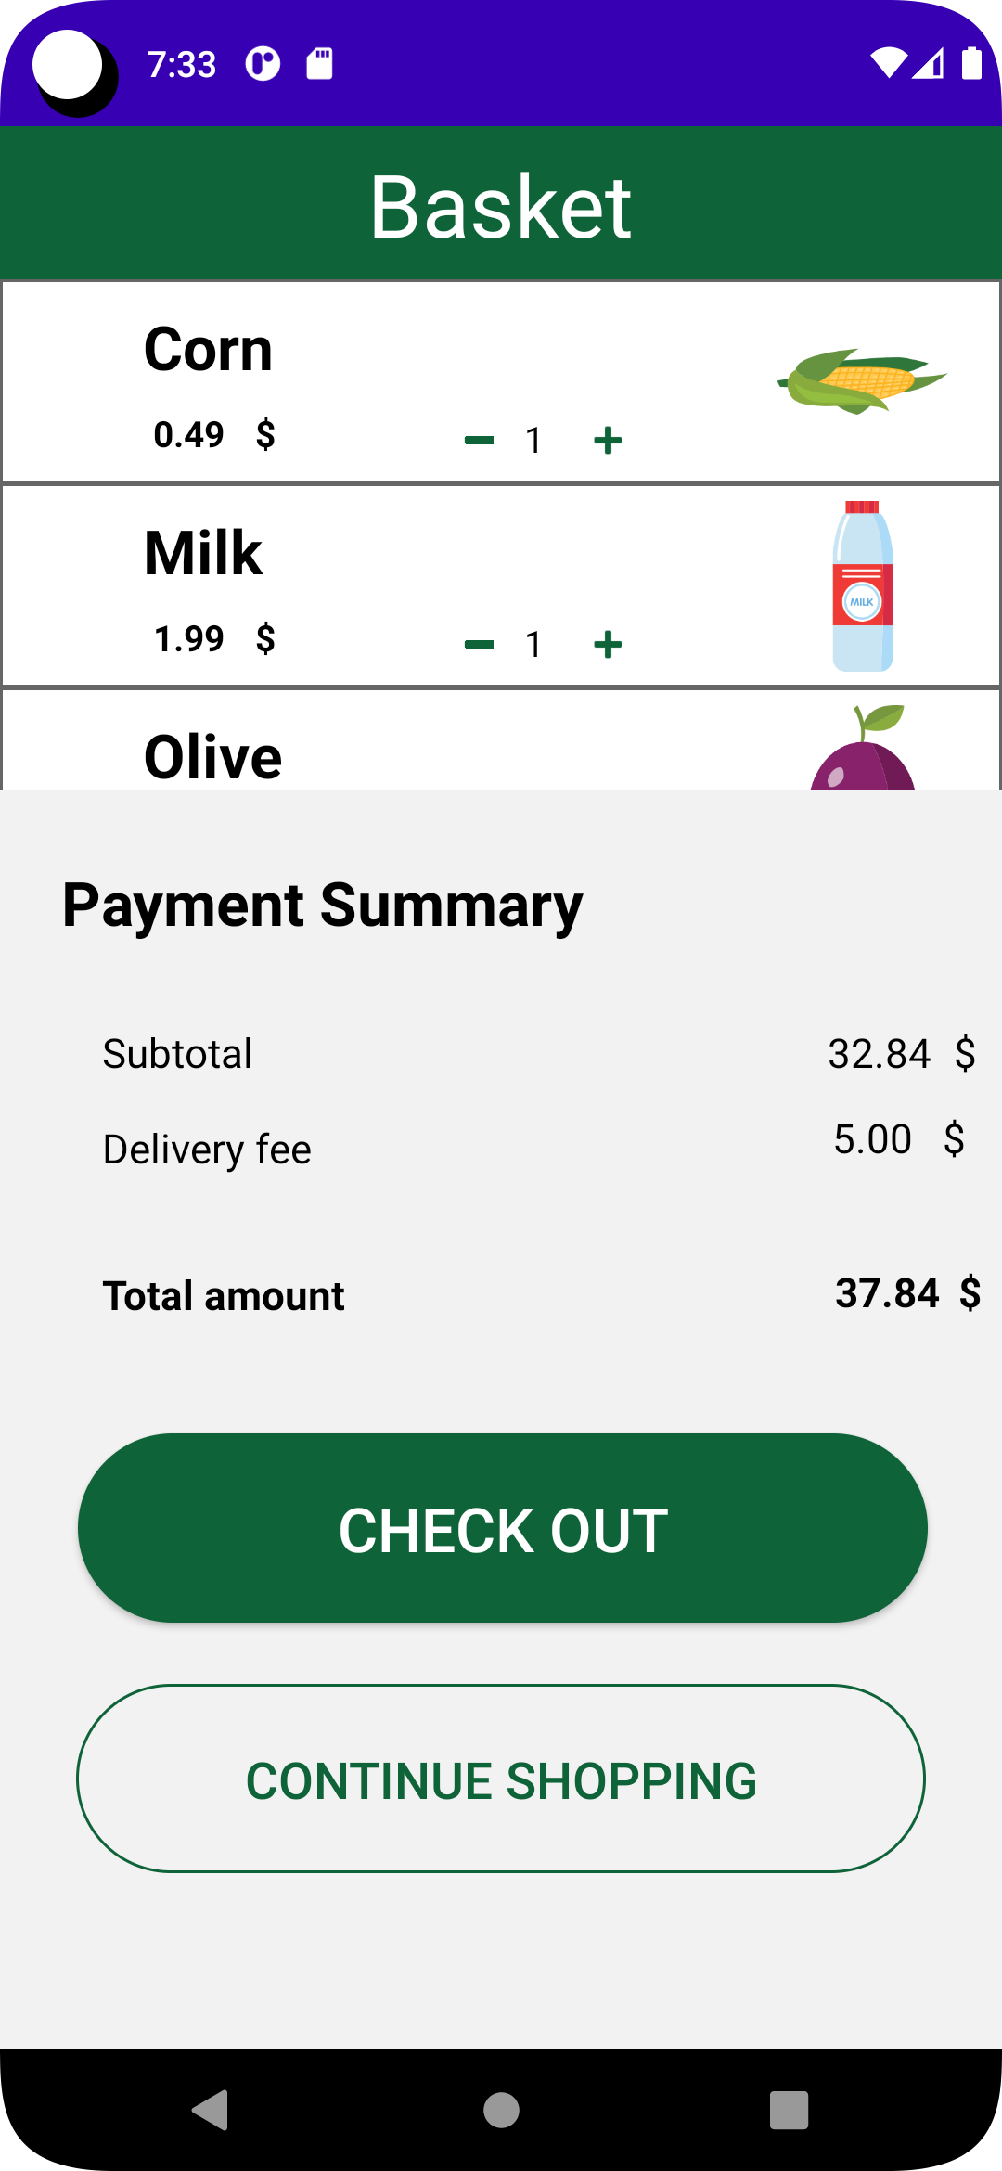

1. if we place order then



  
  
  